Assignment 4: Becoming an Independent Data Scientist

Shastika Bhandari | May 2020.

# Region & Domain

State the region and the domain category that your data sets are about.

Union Territories, India

Economic Activity or Measures

# Research Question

You must state a question about the domain category and region that you identified as being interesting.

How have the Unemployment Rates changed over the past one and half years compared to Indian States for Urban Population?

# Links

You must provide at least two links to publicly accessible datasets. These could be links to les such as CSV or Excel files, or links to websites which might have data in tabular form, such as Wikipedia pages.

* <https://unemploymentinindia.cmie.com/kommon/bin/sr.php?kall=wtabnav&tab=4020>
* <https://tradingeconomics.com/india/unemployment-rate>

# Visualization

You must upload an image which addresses the research question you stated. In addition to addressing the question, this visual should follow Cairo's principles of truthfulness, functionality, beauty, and insightfulness.

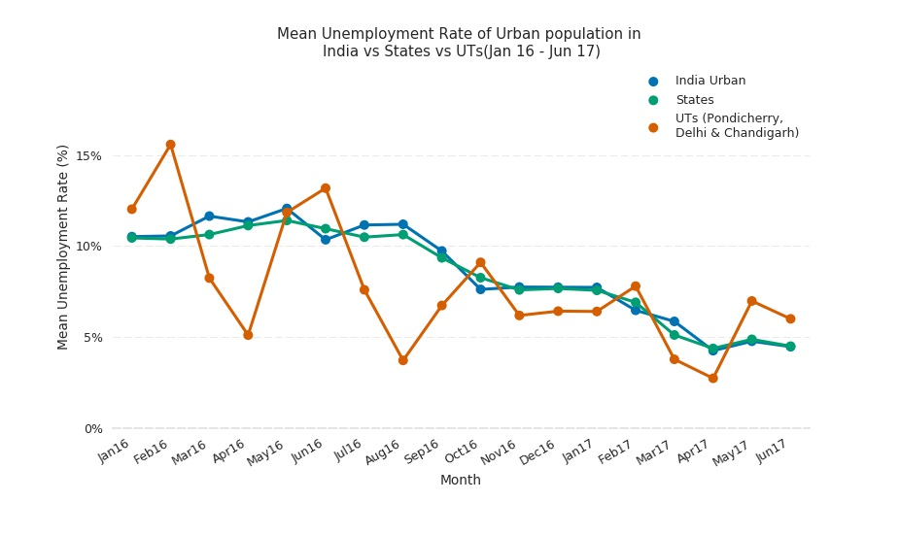

# Discussion

You must contribute a short (1-2 paragraph) written justification of how your visualization addresses your stated research question.

This visualization was concerned with answering the question of how the unemployment rate of Union Territories of India have changed against Indian States and India Overall over the past one and half year for Urban population. The data was collected from CMIE website. CMIE stands for Centre for Monitoring Indian Economy that conducts monthly and weekly surveys over 160,000+ households. Mean employment rates for states and union territories were calculated to help the reader identify any major trends and variations from it.

The Unemployment rate witnesses a decreasing trend over the past 1.5 years from as high as 10.5% in Jan 2016 to 4.5% in Jun 2017. The Union Territories seem to have a very volatile unemployment rate movement by virtue of their population compared to rest of the regions. In the months of February this rate increases each year and similarly in the month of May. The month of April usually has low unemployment rates in Union Territories.

# Discussion

As this assignment is for the whole course, you must incorporate and defend the principles discussed in the first week, specifically, Cairo’s principles of truth, beauty, function, and insight. For each of the following prompts, please provide a response that links each principle to one or more elements of your visual.

* **Truthfulness:** The UTs label has been edited to show that only 3 UTs are shown while the present number of UTs is 7.
* **Beauty:** The colorblind palette has been used to aid colorblind readers to read the visualization
* **Functionality**: Data ink ratio was reduced by removing the frames
* **Insightfulness**: This has been shown in by marking highly volatile UTs in Red and states and India Urban in green and blue respectively.